**Walmart Sales Analysis & Forecasting Report**

**1. Introduction**

This project aims to analyze Walmart’s sales data (10,000 records) to extract valuable insights, forecast future sales trends, and provide data-driven recommendations to improve sales performance post-pandemic.

**2. Tools & Technologies Used**

* **Python**: Data cleaning and preprocessing (**Pandas**), **(****SQLAlchemy,** psycopg2 to connect to PostgreSQL)
* **SQL (PostgreSQL)**: Data storage, querying, and analysis
* **Power BI**: Data visualization and dashboard creation

**3.** **Data Cleaning Steps:**

* Handled missing values: removed null values, as a few records have null values
* Removed duplicates and corrected inconsistent data formats.
* Standardized column names for uniformity.
* Created a new column as Total with the help of the existing columns unit price and quantity

**4.** **PostgreSQL Queries:** Executed SQL queries to extract meaningful insights.

1. Find different payment methods and the number of transactions, number of quantities sold

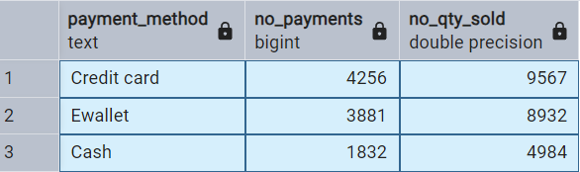

2. Identify the highest-rated category in each branch, displaying the branch, category AVG ranting

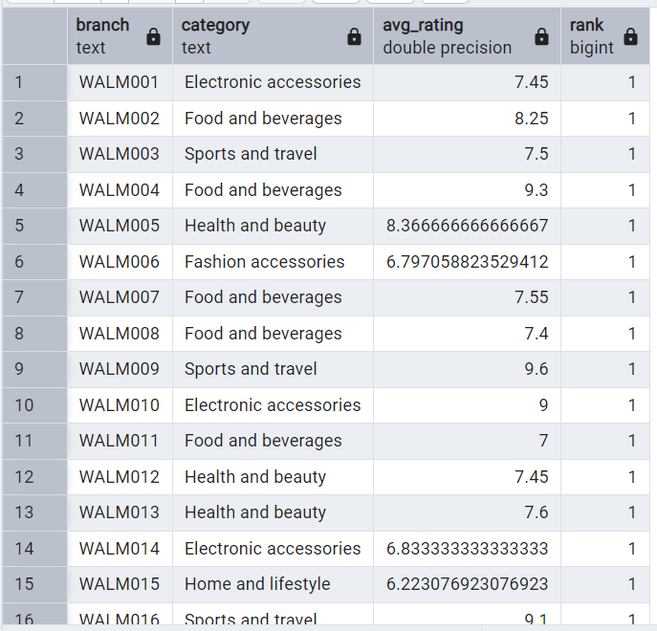

3. Identify the busiest day for each branch based on the number of sales

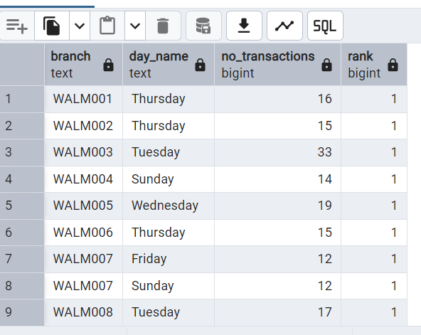

4. Calculate the total quantity of items sold per payment method.List payment_method and total_quantity.

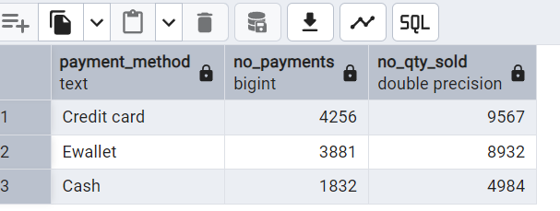

5. Determine the average, minimum, and maximum rating of products for each city,

--list the city, average_rating,min_rating and max_rating.

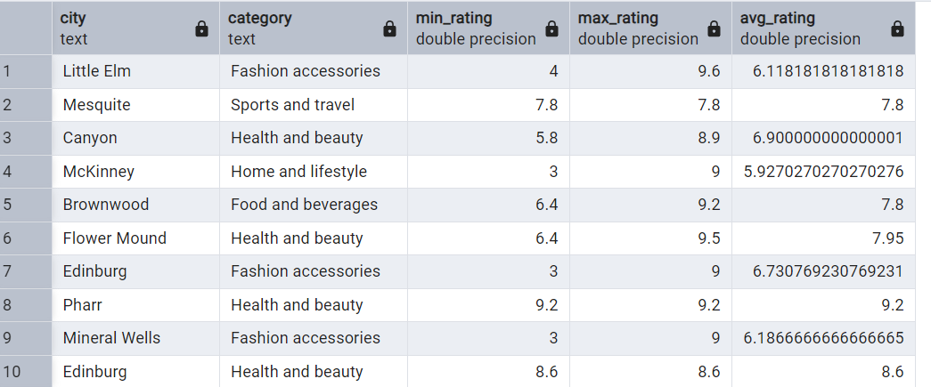

6. calculate the total profit for each category by considering total_profit as

--(unit_price*quantity*profit_margin).List category and total_profit,ordered from highest to lowest profit.

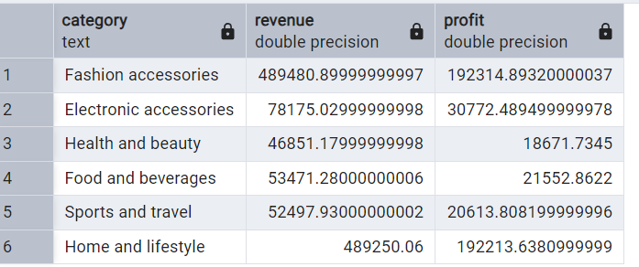

7. Determine the most common payment method for each branch.

--Display the branch and the preferred payment method.

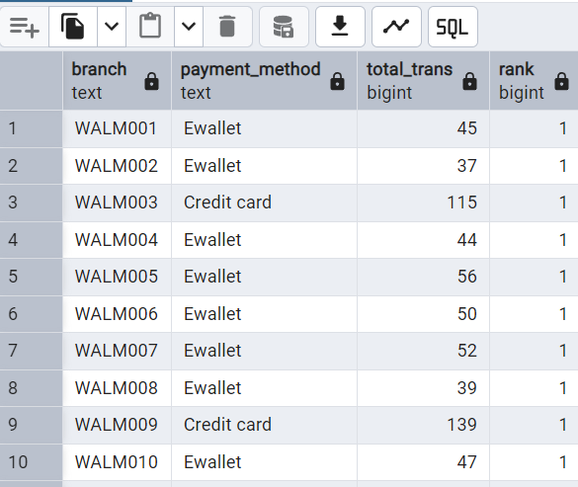

8. Categorize sales into 3 groups: morning, afternoon, evening. Find out which of the shifts

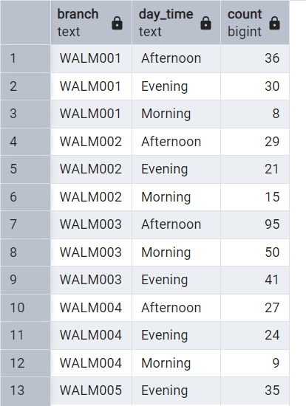

9. Identify 5 branches with the highest decrease in the ratio in

--revenue compared to last year (current year 2023 and last year 2022)

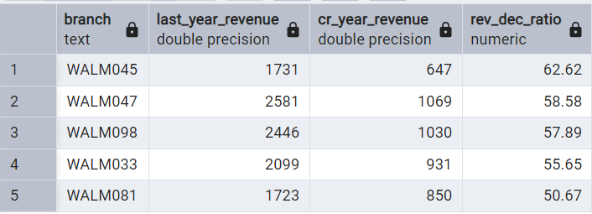

**5. Data Visualization & Dashboard (Power BI)**

**1. Yearly Sales Trend & Forecast (Line Chart with Forecasting)**

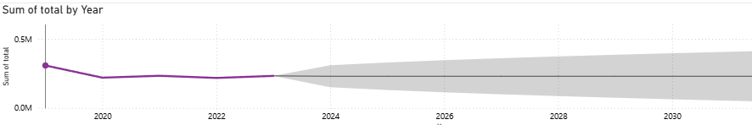

**2.** **Top 5 Best-Selling City**

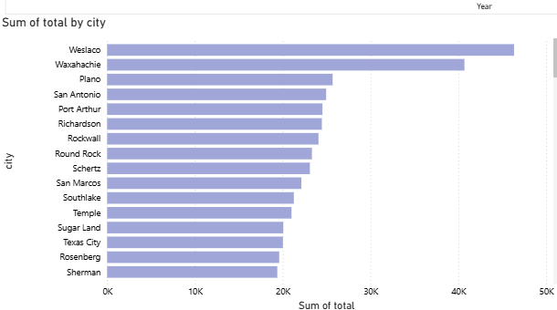

**3. The share in total revenue for different categories**

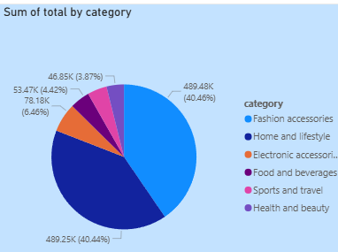

**6. Recommendations Based on Forecasting**

* Launch seasonal discounts & promotions during off-peak months.  
  Stock up on best-selling categories before peak seasons.  
  Leverage targeted marketing campaigns to boost customer retention.
* Expand Digital & E-commerce Channels
* Optimize Pricing & Promotions
* Enhance Customer Loyalty Programs